**CASE STUDY:**

**Retail Store Management System**

Construct a design element for Point of sale terminal management system that can be used for buying and selling of goods in the retail shop.

When the customer arrives at the post check point with the items to purchase. The cashier records each item, price and adds the item information to the running sales transaction. The description and price of the current item are displayed. On completion of the item entry the cashier informs the sales total and tax to the customer. The customer chooses payment type (cash, cheque, credit or debit).After the payment is made the system generates a receipt and automatically updates the inventory. The cashier handovers the receipt to the customer.

**USE Case Diagram:-**

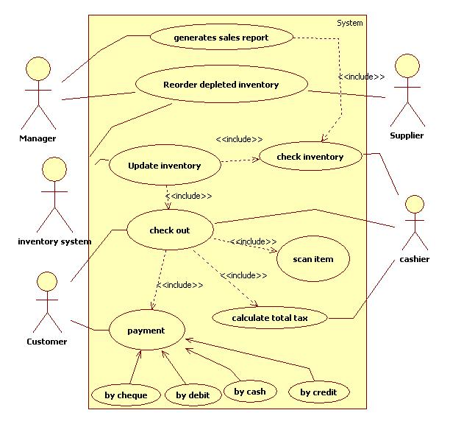

**Activity Diagram :-Sale Transaction**

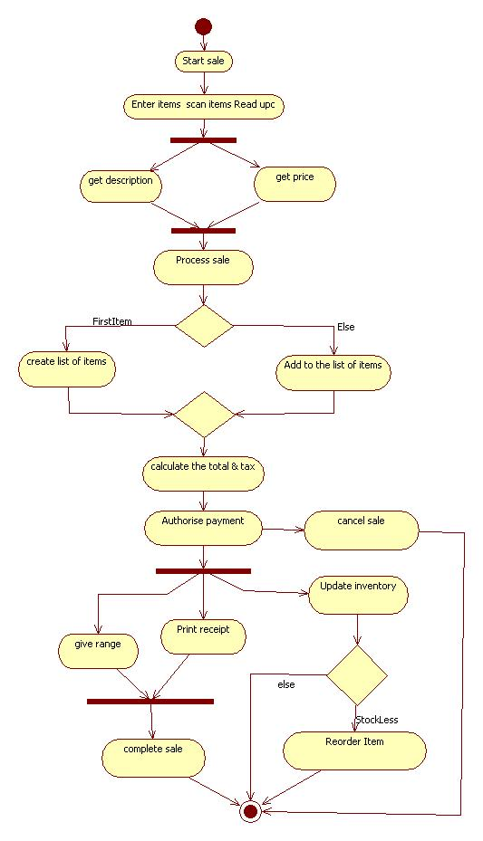

Class Diagram

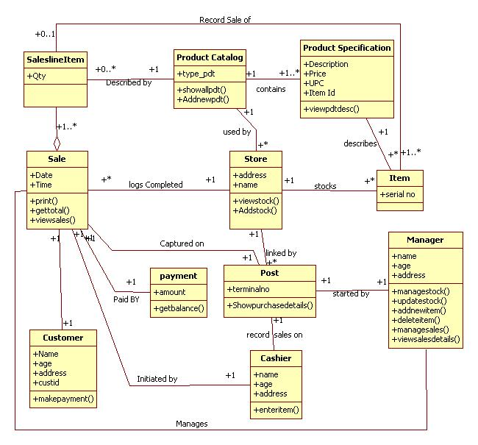

State Chart Diagram

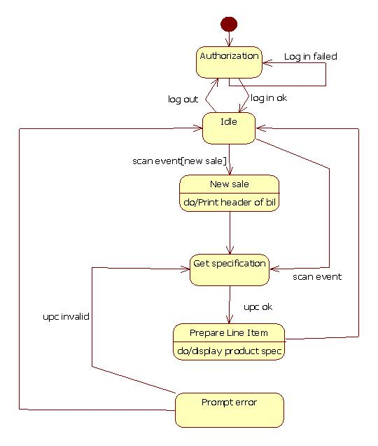

Sequence Diagram

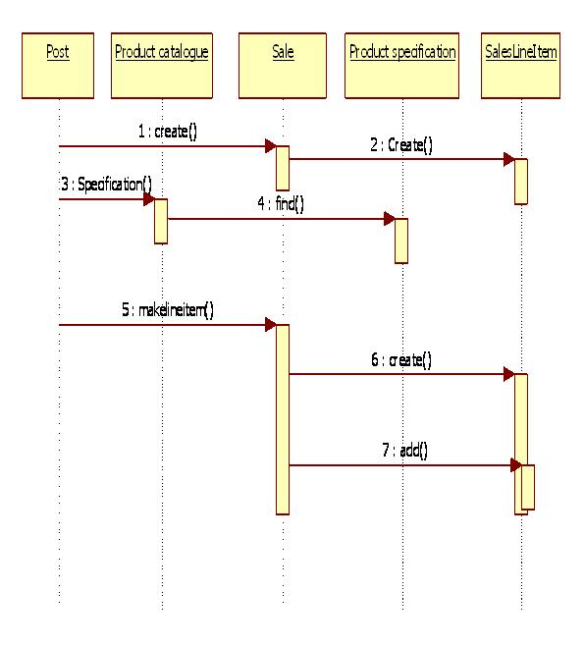

Collaboration Diagram

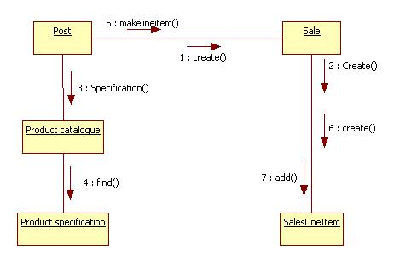

Component Diagram

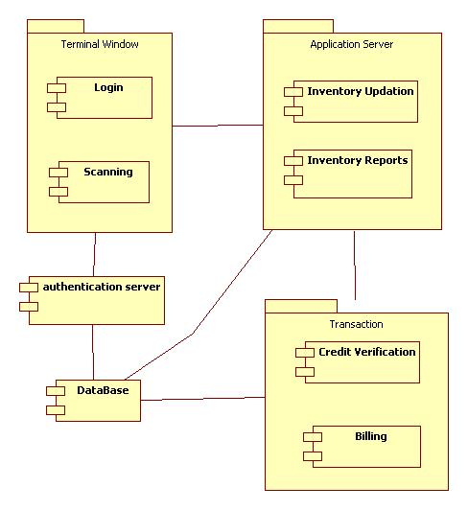

Deployment Diagram

